All-cause Mortality

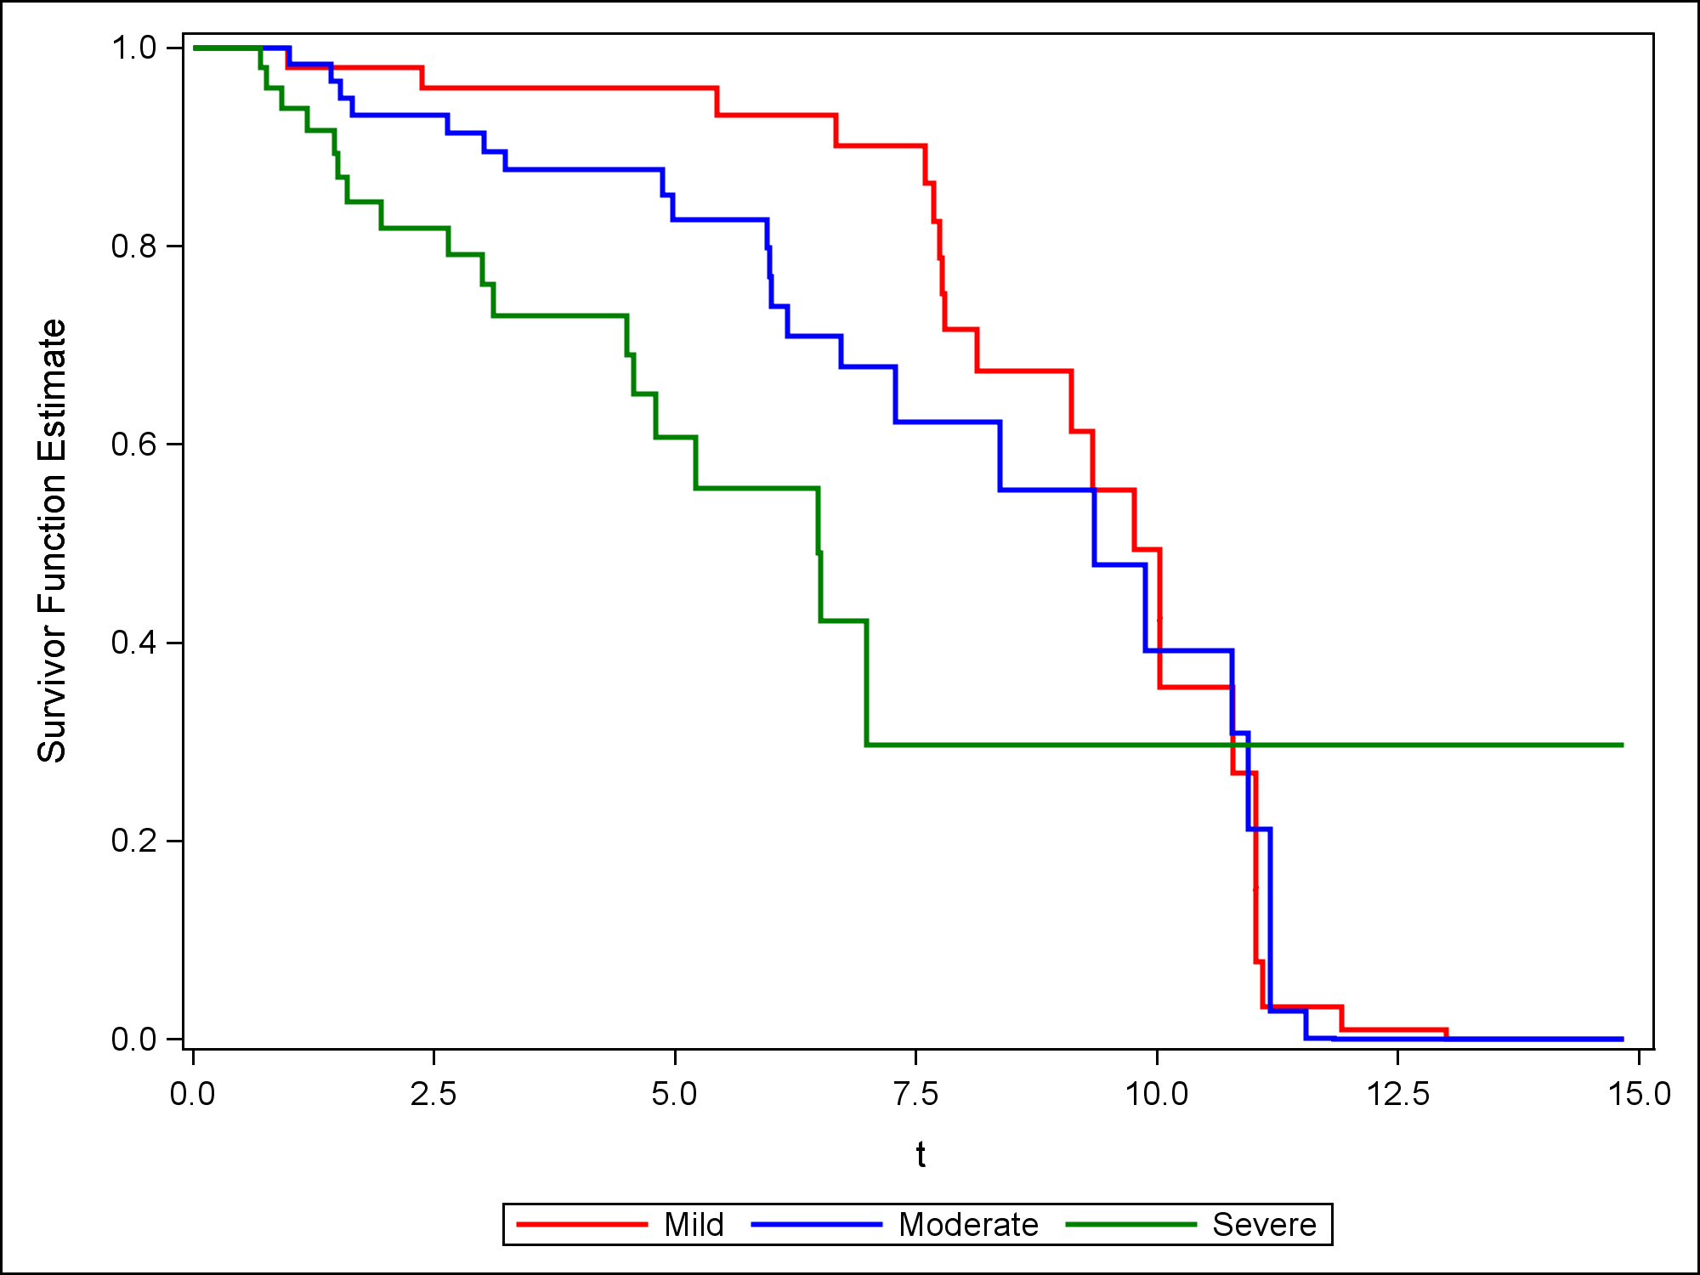

Figure 4: Cox adjusted survival curves for all-cause mortality evaluating the effect of PG on survival in the presence of other covariates (age and sex). Survival was more favorable for both mild (P < 0.0001) and moderate (P < 0.0001) groups when compared to severe.